# Help Document for ICEEMD filter

## Requisites

1. Hoffmans Subject data, utilities and codes [1]
2. Improved Complete Ensemble EMD codes [2]
3. Following Matlab codes (Hari_crossvaltest, ICEEMD_wn, extracttrials_hari, emd, crossvalidate_hari,raw_imffilter, sigfrommodes)

## Folder placement

The MATLAB files (including Hoffmans codes) needs to be place in the same folder as shown below

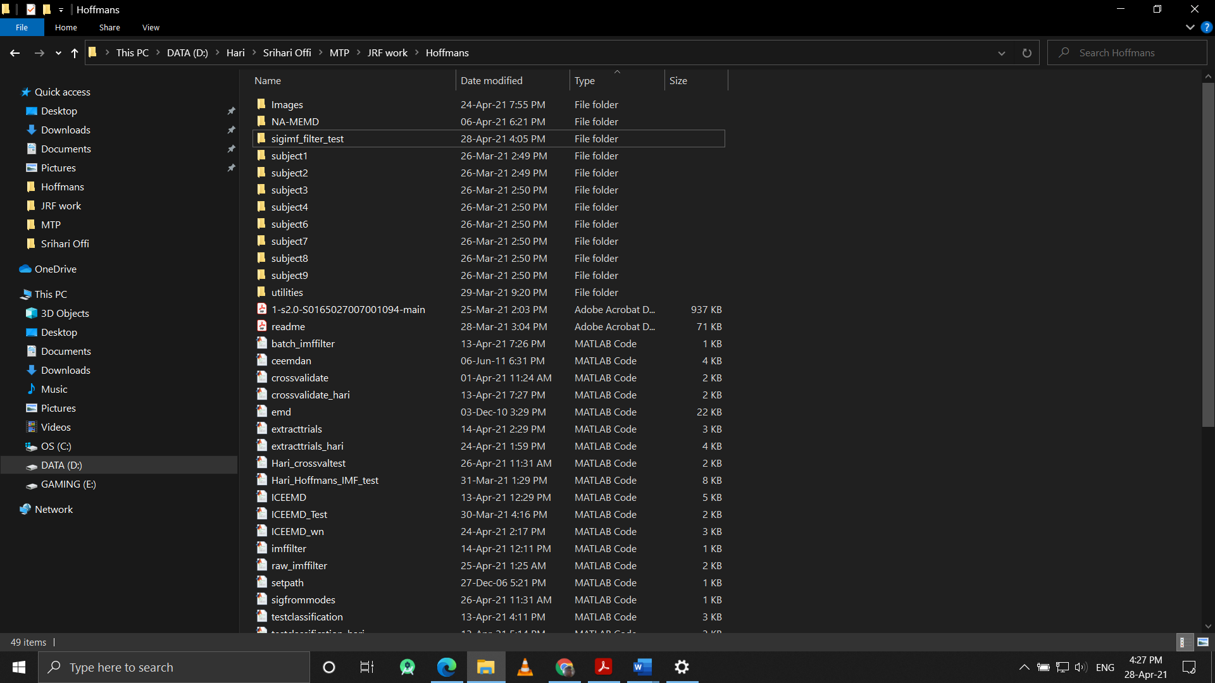

Matlab codes

Subject data

## Important Matlab codes

(Note: For original Hoffman’s code info refer their readme document)

1. **ICEEMD_wn** : Modified ICEEMD code [2] with the white_noise modes being fed directly to the function to reduce redundancy and processing time
2. **emd :** Function for calculating the IMF components in the ICEEMD_wn function
3. **extracttrials_hari :** Modified ‘extracttrials’ code from Hoffman’s, which extracts the EEG data from a session (as indicated by subject) and packages it into 1s long trials cell array in the native 2048 sampling frequency
4. **rawimffilter :** Function to take the packed 2048Hz EEG trials (created by extracttrials_hari) and calculates $\overline{IMF}$ modes of the trials and saves them to a cellarray whose name is given as input. [Note: This function is time consuming and takes 5-6 hours per subject (1-1.5 hours per session) to calculate the IMFs so please run them before hand if possible]
5. **sigfrommodes :** Function to repack filtered signals, made by selectively merging 2 or more $\overline{IMF}$ modes into 32hz trial array. This selection is made by choosing IMFs that contains >70% of their power spectral density, within the desired bandwidth of 1-12 Hz
6. **testclassification_hari :** Modified testclassification codes of Hoffman’s [1], which returns a confusion chart of predictions, for a set of training files and test file.
7. **crossvalidate_hari :** Modified ‘crossvalidate’ file which returns the blockwise correct number of predictions made by the Bayesian-LDA in the trial file list provided as well as accuracies.
8. **Hari_crossvaltest :** Test file to run and test the implementation of the IMF filtering for the EEG data.

## Example of usage

%% Trials with IMF filter (by hari)

imf_channels = [32]; % EEG channels for analysis

setpath %set path to folder to access utility functions

%% Extract raw 2048 Hz signal into trials

sample_sublist = [3]; % subject to analyse

for j = 1:4

trialfilelist{j} = "s" + num2str(sample_sublist)+num2str(j); %File list to store the sessions

end

%% Package filtered signal into trial run matrix

for t = 1:4

extracttrials("subject"+num2str(i)+"\session"+num2str(t)+"\",trialfilelist{t})

end

%% Calculate performance of original Butterworth Filter for comparison

[accuracy_12hz,x]=crossvalidate_hari(trialfilelist); %crossvalidate and store accuracies

%% Calculate the IMF modes for the trials and store to a .mat file

raw_imffilter(trialfilelist,'modes_sub8raw.mat');

%% Packages filtered signal from IMFs into the trial signals

sigfrommodes(trialfilelist,'modes_sub8raw'); % Pack signal

%% Calculate performance of IMF Filter and store accuracies

[accuracy_imf,x]=crossvalidate_hari(trialfilelist);

## References

[1] U. Hoffmann, J. M. Vesin, T. Ebrahimi, and K. Diserens, “An efficient P300-based brain-computer interface for disabled subjects,” *J. Neurosci. Methods*, vol. 167, no. 1, pp. 115–125, 2008, doi: 10.1016/j.jneumeth.2007.03.005.

[2] M. A. Colominas, G. Schlotthauer, and M. E. Torres, “Improved complete ensemble EMD: A suitable tool for biomedical signal processing,” *Biomed. Signal Process. Control*, vol. 14, no. 1, pp. 19–29, 2014, doi: 10.1016/j.bspc.2014.06.009.